Effects of changes to ICT system status

project scope increasing in deliverables

* Measuring the amount of extra work needed to complete new tasks
* Identify what extra resources will be needed to complete new project

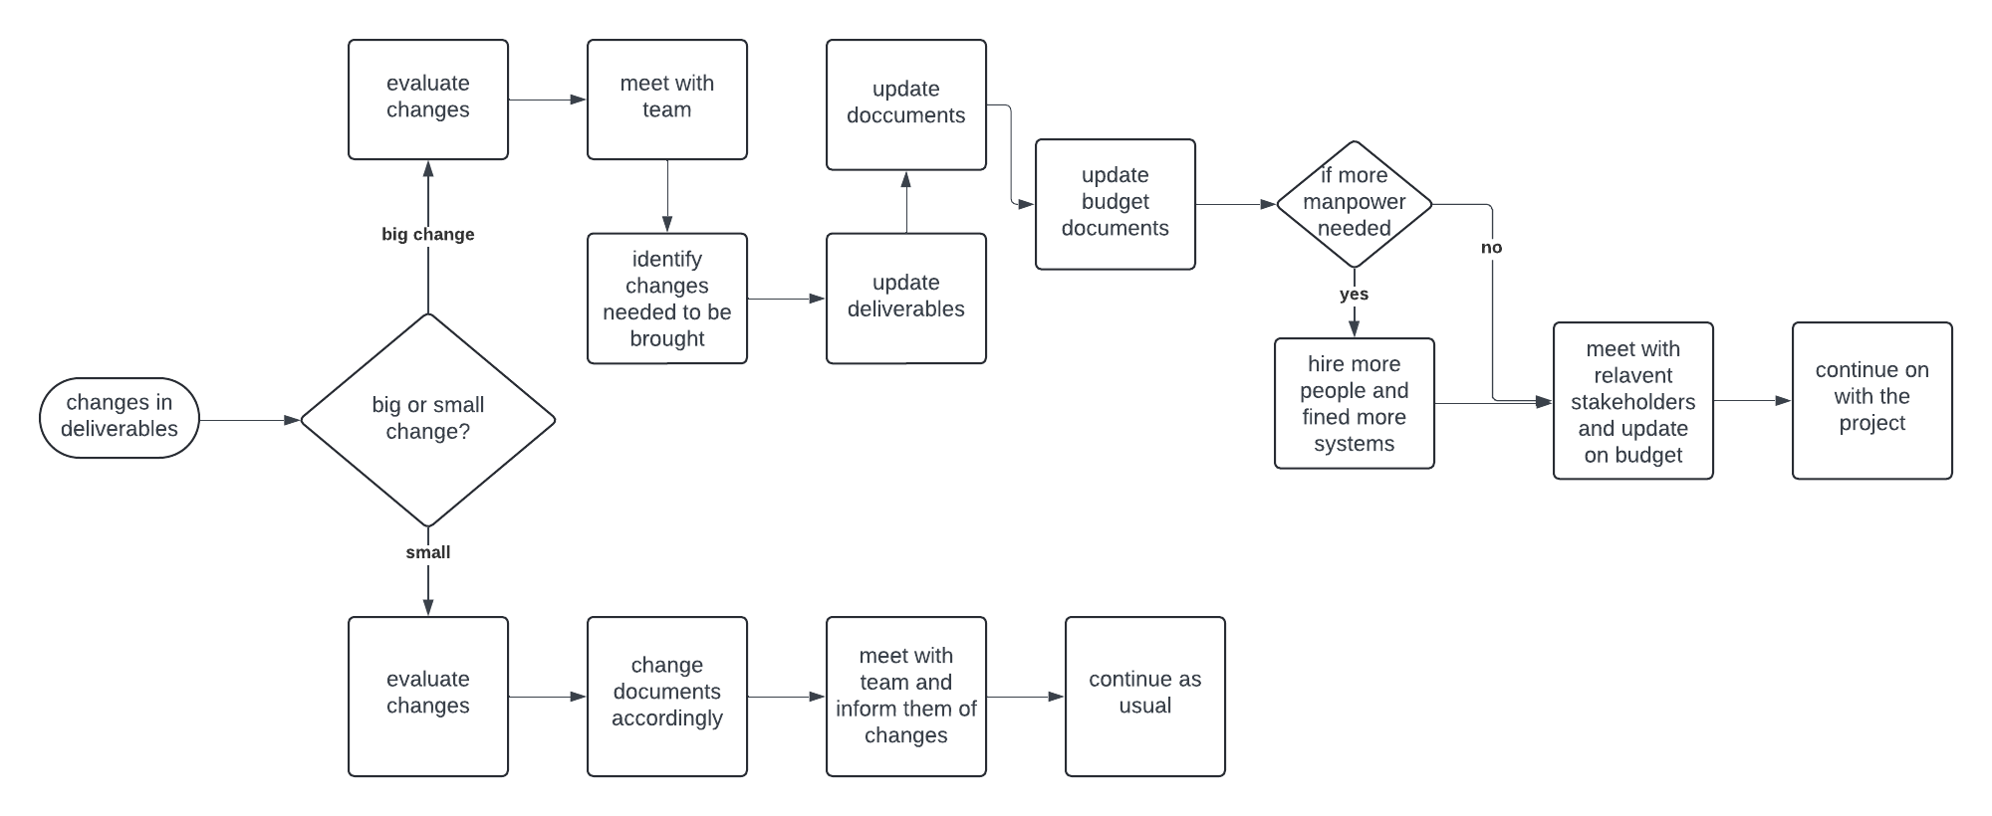

Impacts:

* Delays in project completion
  + Due to more work timeline will be affected
  + More meetings will be held
* Extra manpower needed
  + More people will be needed to work on the project to try and finish it on time
* Extra systems needed
  + Due to more people more systems will be needed
* Increase in budget
  + Increasing in budget because of increase in manpower (salary)
  + Increasing budget due to increase in systems
* Work load of workers will increase
  + More work in a limited time frame to meet deadline
* Changes in the documents
  + Changes will be needed to made to documents as per the changes
  + Customer requirements document will have more changes
  + Dev requirements will also have some changes
  + Scope document might change due to changes in the overall project deliverables

Risks:

* Unrealistic time frame for workers
* Major changes in already finished work may occur
* Not getting enough budget for new parts of the project from external sponsors

Mitigations for said risks

1. Unrealistic time frame for workers
   1. Find out how much more time is needed to complete the project with new requirements
   2. Hold meetings with the clients and explain how much time will be needed
2. Major changes in already finished work may occur
   1. Check what can and cannot be included in the finished work
   2. Remove what cannot be used
   3. Develop a workaround in the already finished work
3. Not getting enough budget for new parts of the project from external sponsors
   1. Identify how much more is needed for the completion of the rest of the work
   2. hold meetings with the stakeholders and explain what is going on